**Practical : 1**

**Aim : Write C program to check a number is even or odd using ternary operator.**

**Program :**

#include<stdio.h>

main()

{

int a;

printf("enter value of a=");

scanf("%d",&a);

(a%2==0) ?printf("a is even number")

:printf("a is odd number");

}

**Output:**

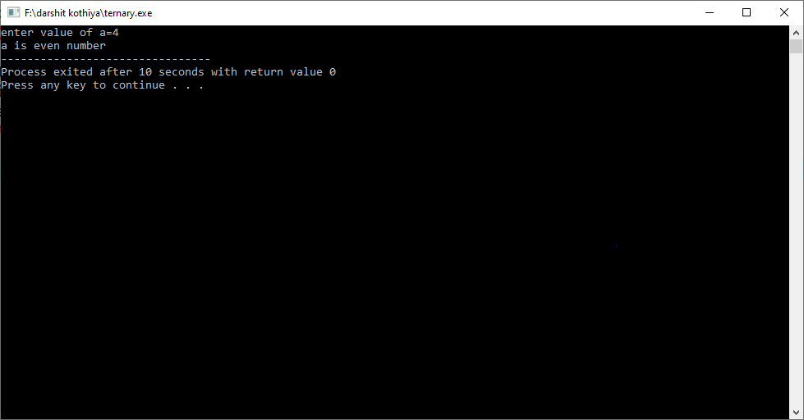

**Practical : 2**

**Aim :Write C program to find out max from 4 numbers using nested if.**

**Program :**

#include<stdio.h>

main()

{

int a, b, c, d;

printf("\n Enter value to a, b, c, d: ");

scanf("%d %d %d %d", &a, &b, &c, &d);

if (a >b)

{

if(a>c)

{

if(a>d)

{

printf("a is max");

}

else

{

printf("d is max");

}

}

else

{

if(c>d)

{

printf("c is max");

}

else

{

printf("d is max");

}

}

}

else

{

if(b>c)

{

if(b>d)

{

printf("b is max");

}

else

{

printf("d is max");

}

}

else

{

if(c>d)

{

printf("c is max");

}

else

{

printf("d is max");

}

}

}

}

**Output:**

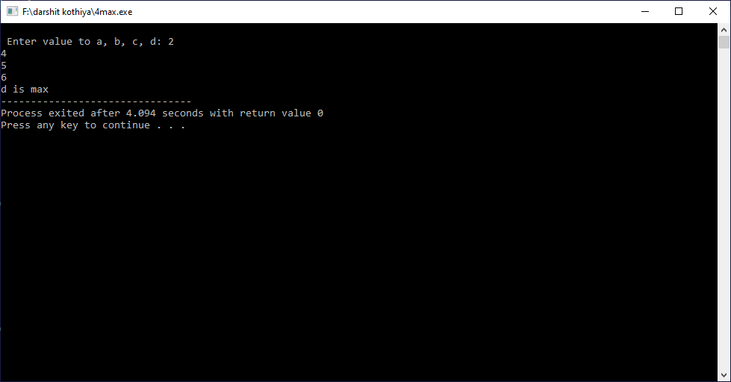

**Practical : 3**

**Aim :Write C program use switch statement. Display Monday to Sunday.**

**Program:**

#include<stdio.h>

main()

{

char day;

printf("enter m for Monday \n");

printf("t for Tuesday\n");

printf("w for Wednesday\n");

printf("h for Thursday\n");

printf("f for Friday\n");

printf("s for Saturday\n");

printf("u for Sunday \n");

printf("...............");

scanf("%c",&day);

switch(day)

{

case 'm':

case 'M':

printf("monday \n");

break;

case 't':

case 'T':

printf("tuesday \n");

break;

case 'w':

case 'W':

printf("wednesday \n");

break;

case 'h':

case 'H':

printf("thursday \n");

break;

case 'f ':

case 'F':

printf("friday \n");

break;

case 's':

case 'S':

printf("saturday \n");

break;

case 'u':

case 'U':

printf("sunday \n");

break;

default:

printf("wrong input \n");

break;

}

}

**Output:**

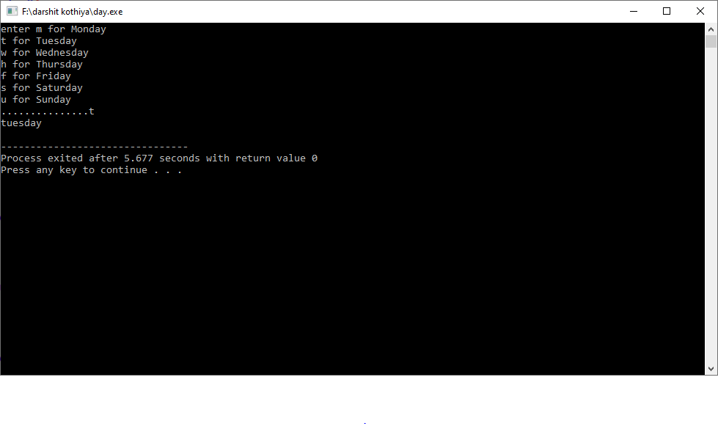

**Practical : 4**

**Aim :Write a C program to input electricity unit charges and calculate total electricity bill according to the given condition:**

**For first 50 units Rs. 0.50/unit**

**For next 100 units Rs. 0.75/unit**

**For next 100 units Rs. 1.20/unit**

**For unit above 250 Rs. 1.50/unit**

**An additional surcharge of 20% is added to the bill.**

**Program:**

#include<stdio.h>

main()

{

int a;

float total, total_amt, sc;

printf("Enter total units consumed: ");

scanf("%d", &a);

if(a <= 50)

{

total = a * 0.50;

}

else if(a <= 150)

{

total= 25 + ((a-50) * 0.75);

}

else if(a <= 250)

{

total = 100 + ((a-150) * 1.20);

}

else

{

total= 220 + ((a-250) * 1.50);

}

sc = total * 0.20;

total_amt = total + sc;

printf("Electricity Bill = Rs. %.2f", total_amt);

}

**Output :**

